Odoo – Timers

Contents

What is a Timer? 1

Timer Rules 1

Starting a Timer 1

Stopping a Timer 2

Timer Warnings 3

View Timers List 3

Deleting a Timer 3

# What is a Timer?

Timers allow you to track your working time by starting and stopping a timer. Then you can easily create a time entry when you stop the Timer. Timer’s are available on Project Tasks and Helpdesk Tickets.

# Timer Rules

There have been several rules put in place for Timers:

* Only one timer can run for each person.
* Multiple users can have a Timer running on a Project Task or a Helpdesk Ticket.
* Users can only start and stop their own Timers.
* Timers are only available on Tickets that are linked to Projects.

# Starting a Timer

Timers are started and stopped directly on the record’s form.

1. Open the Helpdesk Ticket or Project Task.
2. Click the start timer icon.

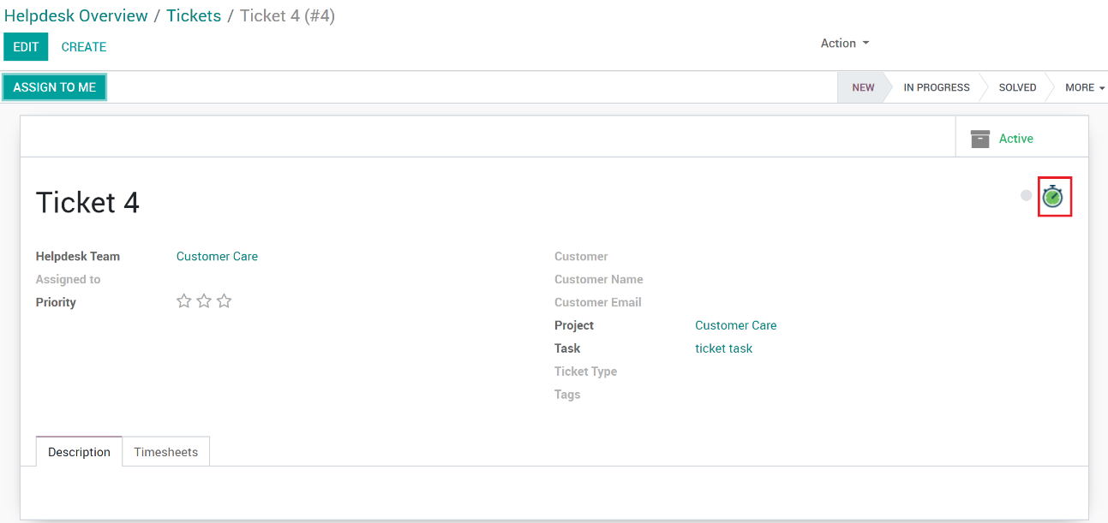

1. You will see new icons appear showing that one or more timers is running as well as the stop timer icon.

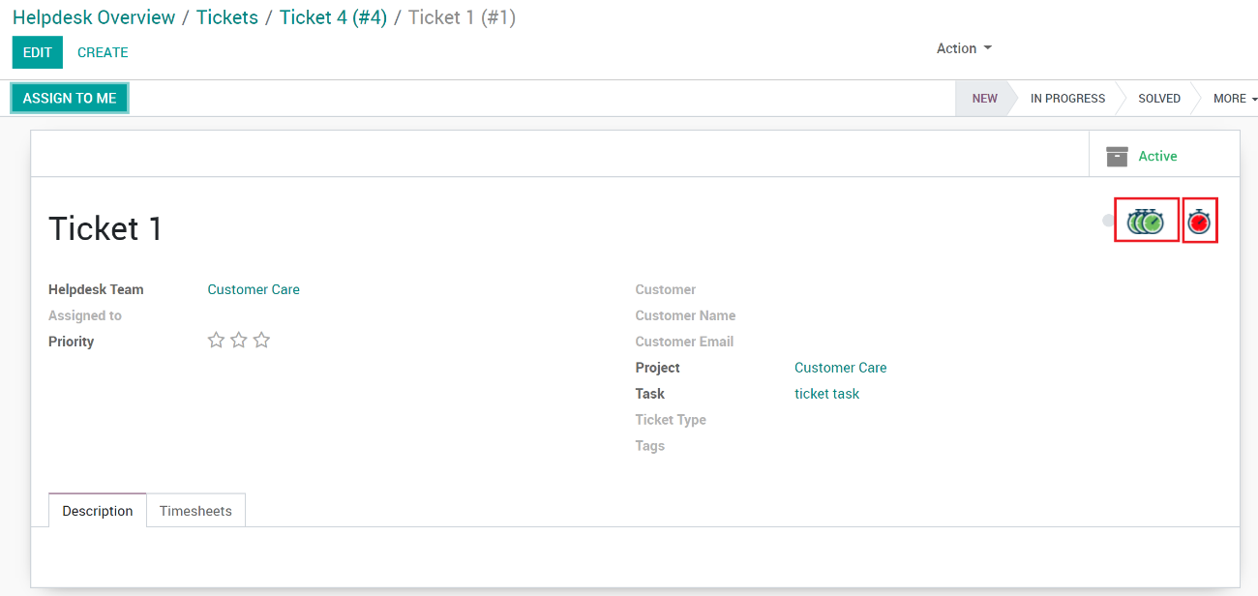

1. Other users can click the start timer icon to start their own timer.

**Note**: Helpdesk Tickets and Project Tasks that have running timers show a timer icon on their Kanban cards.

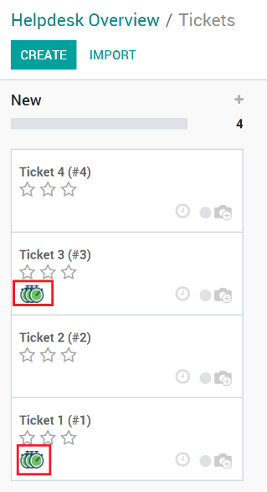

# Stopping a Timer

Stopping a timer is as easy as starting one.

1. Open the Helpdesk Ticket or Project Task.
2. Click the start timer icon.
3. A wizard window will open to fill in information for the time entry.

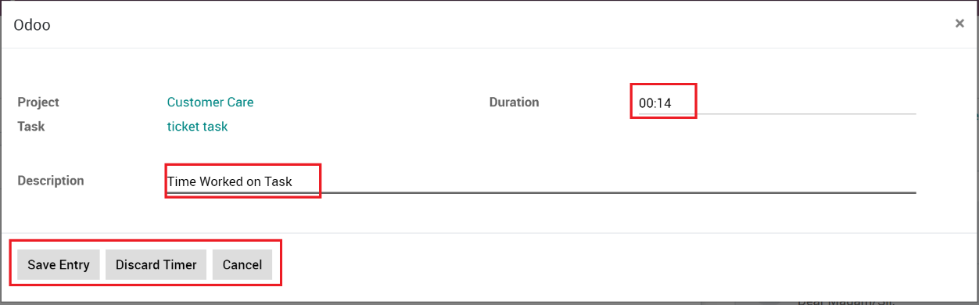

* 1. **Project**: Shows the project this time entry will be related to.
  2. **Task**: Shows the project task this time entry will be related to.
  3. **Duration**: The time between starting and ending the timer. This can be changed if adjustments are needed. Format hh:mm.
  4. **Description**: A general description of the time entry. Defaults to “Timer Worked on Task/Ticket”

1. Press any of the buttons to finish the wizard.
   1. **Save Entry**: Saves a time sheet entry with the provided information.
   2. **Discard Timer**: Deletes the Timer so a new one can be started. No information is recorded.
   3. **Cancel**: Cancels and closes the wizard form. No actions are taken.

# Timer Warnings

While using Timer, there are some warning messages that may popup due to the rules explained earlier.

* If you already have a timer running on another record and you are attempting to start another, a message will popup and provide a button to either the Helpdesk Ticket or a Project Task that the timer is running on so you can finish it.  
   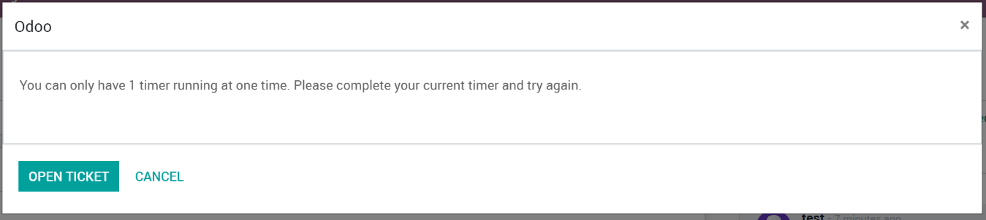
* If you try to stop someone else’s timer, a message will popup showing you that you have no timers on the current record you are viewing.  
  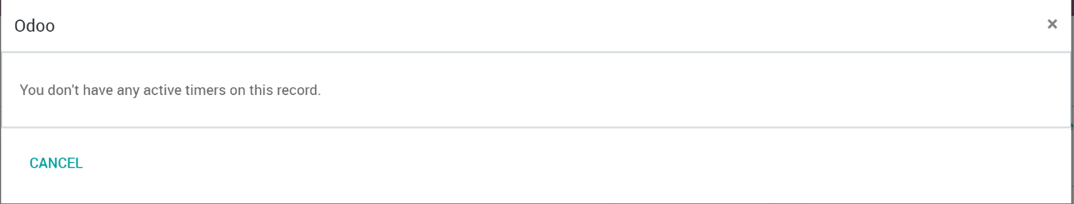

# View Timers List

Users with manager permissions can view the list of active timers.

1. Open either in Project or Helpdesk apps.
2. Go to the **Configuration** menu then **All Timers**.

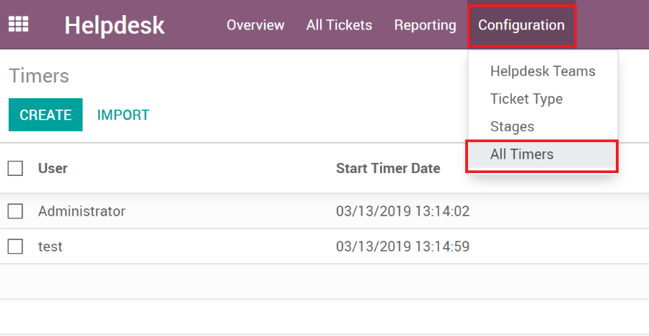

# Deleting a Timer

Timers can be deleted by users with manager permissions but only should be done so if the user who started the timer can’t stop it themselves.

To delete a timer:

1. Go to the Timer List.
2. Select the timer to delete.
3. Go to **Actions**, then **Delete**

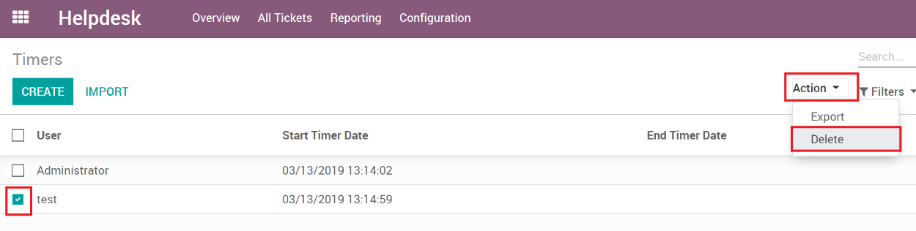

1. Confirm you want to delete the timer.

IMPORTANT: Once deleted, there is no way to recover the timer.

IMPORTANT: When a timer gets deleted, it can’t reset the ‘timer_started’ field on the record it was initially run so you will still see that it’s showing timers are running on it, even though you deleted it.

To fix this, just open the record and start a new timer and then stop it, pressing the discard timer button will set the record back to normal.